function varargout = savepopup(varargin)
% SAVEPOPUP MATLAB code for savepopup.fig
% SAVEPOPUP, by itself, creates a new SAVEPOPUP or raises the existing
% singleton*.
%
% H = SAVEPOPUP returns the handle to a new SAVEPOPUP or the handle to
% the existing singleton*.
%
% SAVEPOPUP('CALLBACK',hObject,eventData,handles,...) calls the local
% function named CALLBACK in SAVEPOPUP.M with the given input arguments.
%
% SAVEPOPUP('Property','Value',...) creates a new SAVEPOPUP or raises the
% existing singleton*. Starting from the left, property value pairs are
% applied to the GUI before savepopup_OpeningFcn gets called. An
% unrecognized property name or invalid value makes property application
% stop. All inputs are passed to savepopup_OpeningFcn via varargin.
%
% *See GUI Options on GUIDE's Tools menu. Choose "GUI allows only one
% instance to run (singleton)".
%
% See also: GUIDE, GUIDATA, GUIHANDLES
% Edit the above text to modify the response to help savepopup
% Last Modified by GUIDE v2.5 06-Mar-2019 10:01:38
% Begin initialization code - DO NOT EDIT
gui_Singleton = 1;
gui_State = struct('gui_Name', mfilename, ...
'gui_Singleton', gui_Singleton, ...
'gui_OpeningFcn', @savepopup_OpeningFcn, ...
'gui_OutputFcn', @savepopup_OutputFcn, ...
'gui_LayoutFcn', [] , ...
'gui_Callback', []);
if nargin && ischar(varargin{1})
gui_State.gui_Callback = str2func(varargin{1});
end
if nargout
[varargout{1:nargout}] = gui_mainfcn(gui_State, varargin{:});
else
gui_mainfcn(gui_State, varargin{:});
end
% End initialization code - DO NOT EDIT
% --- Executes just before savepopup is made visible.
function savepopup_OpeningFcn(hObject, eventdata, handles, varargin)
% This function has no output args, see OutputFcn.
% hObject handle to figure
% eventdata reserved - to be defined in a future version of MATLAB
% handles structure with handles and user data (see GUIDATA)
% varargin command line arguments to savepopup (see VARARGIN)
% Choose default command line output for savepopup
handles.output = hObject;
% Update handles structure
guidata(hObject, handles);
% UIWAIT makes savepopup wait for user response (see UIRESUME)
% uiwait(handles.figure1);
% --- Outputs from this function are returned to the command line.
function varargout = savepopup_OutputFcn(hObject, eventdata, handles)
% varargout cell array for returning output args (see VARARGOUT);
% hObject handle to figure
% eventdata reserved - to be defined in a future version of MATLAB
% handles structure with handles and user data (see GUIDATA)
% Get default command line output from handles structure
varargout{1} = handles.output;
% --- Executes on button press in commasave.
function commasave_Callback(hObject, eventdata, handles)
% hObject handle to commasave (see GCBO)
% eventdata reserved - to be defined in a future version of MATLAB
% handles structure with handles and user data (see GUIDATA)
savetype=1;
uiresume
setappdata(0,'stype',savetype);
%save('temp.mat','savetype')
guidata(hObject, handles);
close savepopup
% --- Executes on button press in periodsave.
function periodsave_Callback(hObject, eventdata, handles)
% hObject handle to periodsave (see GCBO)
% eventdata reserved - to be defined in a future version of MATLAB
% handles structure with handles and user data (see GUIDATA)
savetype=2;
uiresume
setappdata(0,'stype',savetype);
%save('temp.mat','savetype')
guidata(hObject, handles);
close savepopup
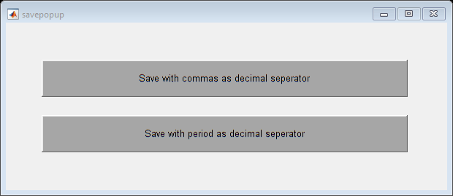
Published with MATLAB® R2018b

